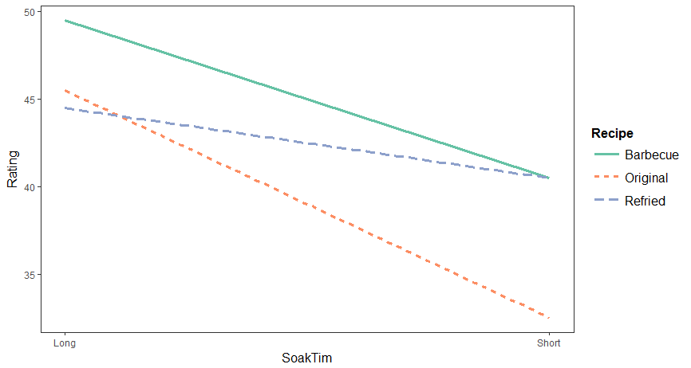

By observing the graph above, we can see that at long soak time, beans with original recipes and refried recipes have the similar taste rating score but have lower taste rating score than beans with barbecue recipes. At short soak time, beans with barbecue recipes and refried recipes have similar teats rating score but have higher taste rating score than beans with original recipes. Also, the shorter the soak time, the lower the taste rating score. In general, beans with barbecue recipes tend to have higher taste rating score than beans with original recipes; beans with long soak time tend to have higher taste rating score than beans with short soak time.